Supplemental Figure 1
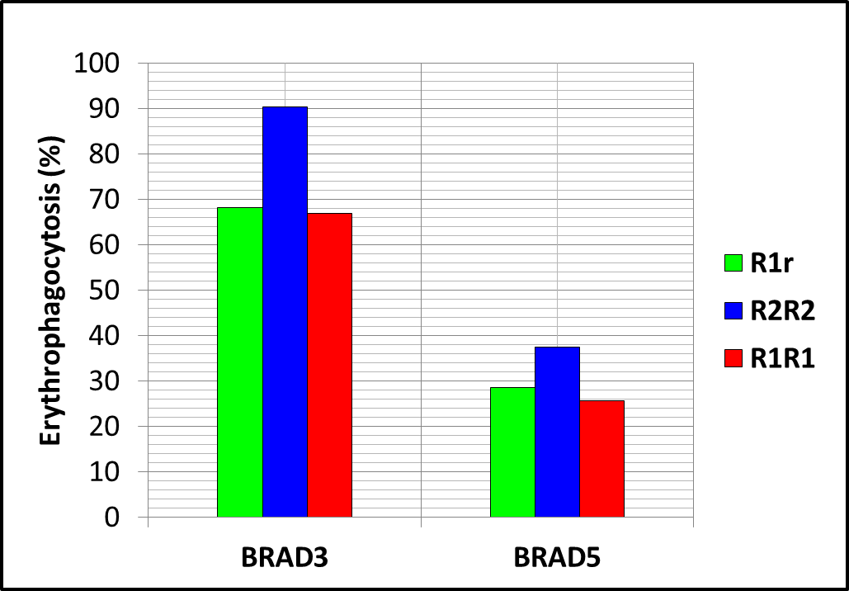
Variation in phagocytosis per Rh D density. CFDA-SE labeled Group O+ RBCs (R2R2, R1R1, and R1r) were sensitized with saturating dilutions of RhD IgG3 (BRAD3, 1:800) and IgG1 (BRAD5, 1:100) at 37C for 30 minutes and erythrophagocytosis was performed as detailed in Material and Methods section of the manuscript. IAT anti-IgG for 1:800 BRAD3 or 1:100 BRAD5 sensitized RBCs ≥2+. Monocyte phagocytosis was observed to be proportional to the density of Rh D antigen on the surface of RBCs. A) BRAD3 sensitization: Monocytes phagocytosed BRAD3 sensitized R2R2 RBCs (90%) more than R1R1 (67%) and R1r (68%). B) BRAD5 sensitization: Monocytes phagocytosed BRAD5 sensitized R2R2 RBCs (38%) more than R1R1 (26%) and R1r (29%). IAT: indirect antiglobulin test, RBCs: red blood cells. A 1:800 BRAD3 and 1:100 BRAD5 dilutions of anti D IgGs was chosen as it gave a hemagglutination score of ≥2+s, needed for a phagocytic index ≥80.¹⁸

Supplemental Figure 2
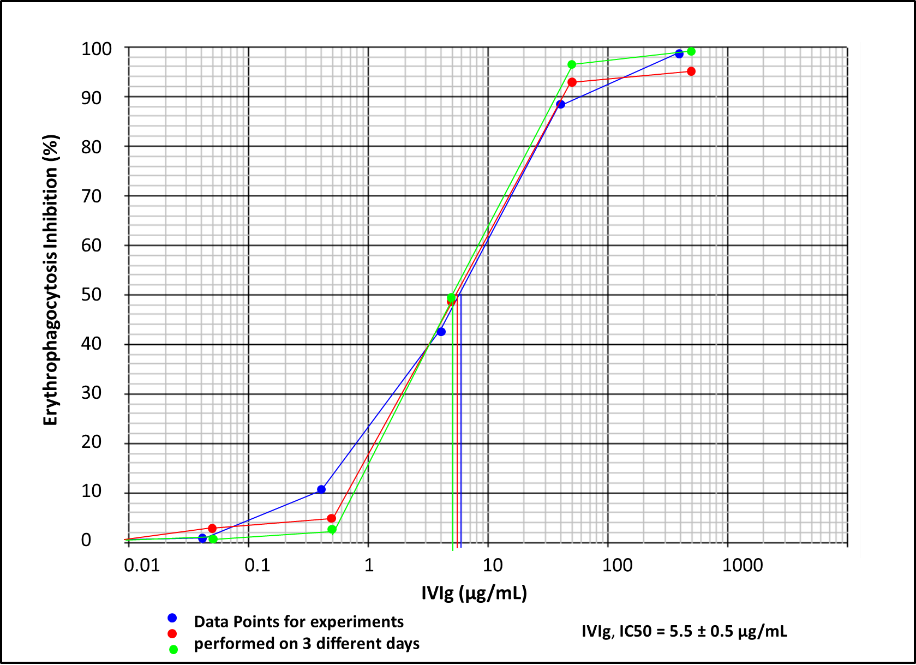
Inhibition of FcγR mediated phagocytosis by IVIG. IVIG inhibition assay was performed 3 times using the same source of monocytes. CFDA-SE labeled, BRAD3 (1:800) sensitized Group O R2R2 RBCs were incubated with monocytes and IVIG at the final concentrations indicated in the graph. IVIG inhibited FcγR mediated phagocytosis in a dose dependent fashion with an IC50 = 5.5 ± 0.5 µg/mL (n = 3). IC50: IVIG concentration at which erythrophagocytosis was reduced to 50%, IVIG: intravenous immunoglobulin, RBCs: red blood cells.

Supplemental Figure 3
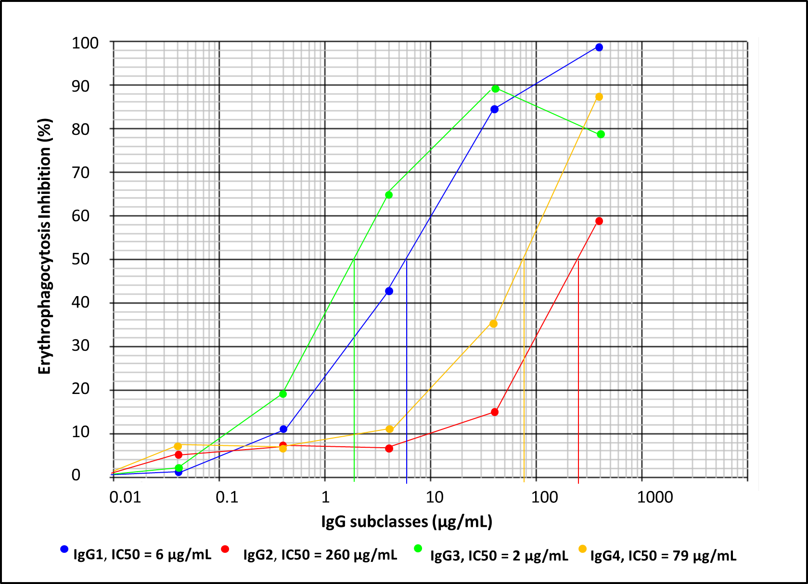
Inhibition of FcγR mediated phagocytosis by IgG subclasses. IgG subclass inhibition assay was performed, in which CFDA-SE labeled, BRAD3 (1:800) sensitized Group O R2R2 RBCs were incubated with monocytes and IgG subclasses at the final concentrations indicated in the graph. IgG subclasses inhibited FcγR mediated phagocytosis in a dose dependent fashion. IgG1 and IgG3 inhibited 50% erythrophagocytosis (IC50) at lower concentrations than IgG2 and IgG4. IC: inhibitory concentration, RBCs: red blood cells.

Supplemental Figure 4
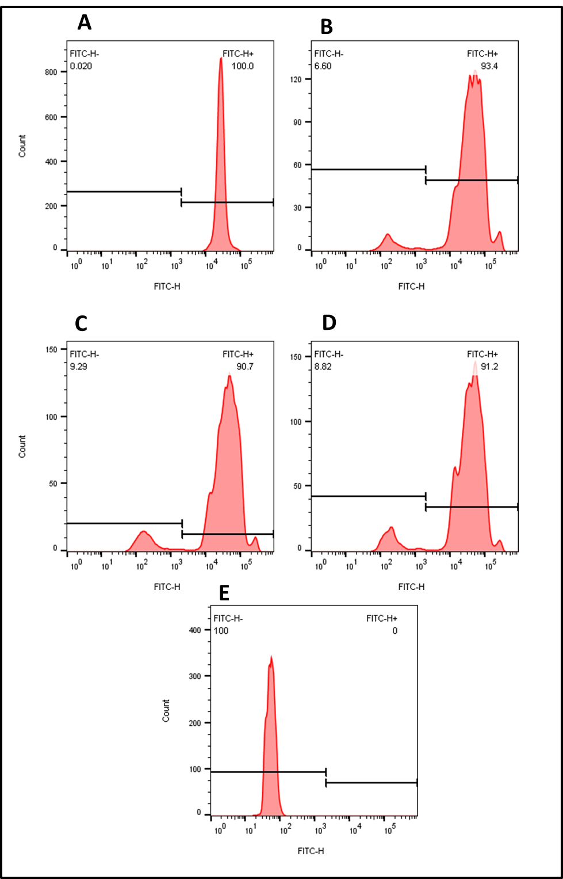
Effect of diluent on monocyte mediated erythrophagocytosis. Percent erythrophagocytosis of CFDA-SE stained RBCs (A) was observed to remain similar when 1/800 BRAD3 prepared in different diluents 0.2%BSA/PBS (B), Plasma (C), and Serum (D) was used for the sensitization of RBCs. Control (E): Un-opsonized RBCs incubated with monocytes for the erythrophagocytosis. RBCs: red blood cells.

